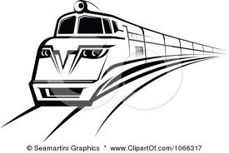
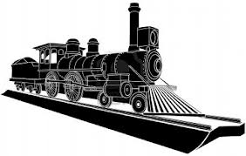
Railway Project
Linking Canada and the UAE

Purpose:
Congratulations on being named the head engineer, marketing director and newspaper columnist for the new train coming to the UAE! In this job, you will be using what you learned about the CPR and applying it to constructing a new train system in the UAE.
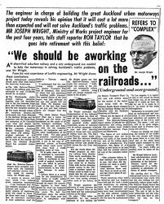
Presentation Format:
Newspaper advertisement! This will be created in computer class, using publishing software to make it look professional!
Requirements Checklist:
What to include: | Details needed:
Newspaper information | - Printing date  - Author’s name (this is you!)  - Newspaper name
Article Title | - Catchy title about the new railway being built in the UAE
Vision for the project | - Why the UAE needs a new train system  - Who will benefit from it being built  - What will it look like  - Where will it go  - When your project is expected to start and end
Background connection to the CPR | - When was the CPR built  - Why was its construction important to Canada  - Similarities and differences of building conditions between Canada and the UAE
Recruit Workers | - Explain that you looking for workers to help create history by being part of this project  - List character traits required of workers
Science and Innovation | - What type of technology will the train have?  - How is this design an improvement from the CPR
Images | - 1-2 images that relate to the newspaper article

