Practice Booklet for Multiplication & Division (Unit 3)
Topic 1: Multiplication
1. Write four related facts for each set of numbers:
a) 8, 9, 72 __________________________________________
b) 6, 8, 48 __________________________________________

2. Find each product.
a) 8 × 0 = ______ b) 5 × 5 = ______ c) 6 × 2 = ______
d) 8 × 1 = ______ e) 7 × 4 = ______ f) 0 × 9 = ______

3. Multiply.
a) 7 × 60 = _____ b) 9 × 80 = _____ c) 7 × 90 = ______
d) 7 × 80 = _____ e) 7 × 800 = ____ f) 7 × 8000 = _____

4. Multiply.
a) 30 × 40 = ______ b) 50 × 50 = ______ c) 60 × 70 = ______
d) 3 × 800 = ______ e) 9 × 50 = ______ f) 6 × 7000 = _____

5. How much money in total?
a) Five $10 bills = ______ b) Thirteen $100 bills = ______
c) Thirty $10 bills and forty $50 bills = ______

6. Shayle puts eight $20 bills and fifteen $10 bills into a cash register.
How much money did she put in the cash register? ______

7. The goal of CIS is to sell 1500 raffle tickets.
Four hundred tickets are sold each week.
Will 1500 tickets be sold in 4 weeks?
_____________________
Topic 2: Multiplication with estimation

1. Round to the nearest 10 for each number.
a) 67 ______ b) 89 ______ c) 32 ______ d) 94 ______

2. Round to the nearest 100 for each number.
a) 460 ______ b) 720 _____ c) 910 _____ d) 880 ______

3. Estimate each product. Tell if your estimate is an overestimate,
an underestimate.
a) 34 × 67 ______ b) 81 × 74 ______

4. There are 36 rows of chairs at the Fine Arts night in the gym.
There are 18 chairs in each row.
About how many chairs are in the gym? _________

5. Daniel delivers the newspaper every day of the week.
He delivers 72 papers a day.
a) About how many newspapers does he deliver in 1 week? ______

b) About how many newspapers does he deliver in 1 month? ______

Topic 3: Multiplication by splitting into expanded form
1. Multiply by splitting into expanded form.
a) 7 × 399 = ______ b) 9 × 502 = ______

c) 8 × 25 = ______ d) 6 × 62 = ______

3. Faris works 40 hours a week. He is paid $12 an hour.
a) How much does he make in 1 week? _______

b) How much does he make in 3 weeks? _______

4. Crystal wants to make 24 towers using 55 blocks for each tower.
How many blocks will she use altogether? _______

8. Multiply.
a) 42 b) 28
× 28 × 34

c) 67 d) 74
x 19 x 86

Topic 4: Basic Division
1. Divide.
a) 36 ÷ 6= ___ b) 80 ÷ 8= ____ c) 49 ÷ 7= ____

d) 56 ÷ 7= ____ e) 28 ÷ 4= ____ f) 46 ÷ 6= ____

g) 32 ÷ 2= ____ h) 12 ÷ 4= ____ i) 35 ÷ 5= ____

2. Six hundred forty-five notebooks are packaged in packs of 7.
About how many packs will there be? _______

3. Four hundred ten pencils are packaged in pencil cases of 4.
About how many pencil cases are filled? _______

4. There are 9 chapters in a book.
There are 458 pages in the book.
The chapters have about the same number of pages.
About how many pages are in each chapter? ______________

Topic 5: Division with Base 10 Blocks

1. Use Base Ten Blocks to find 424 ÷ 4. ______________
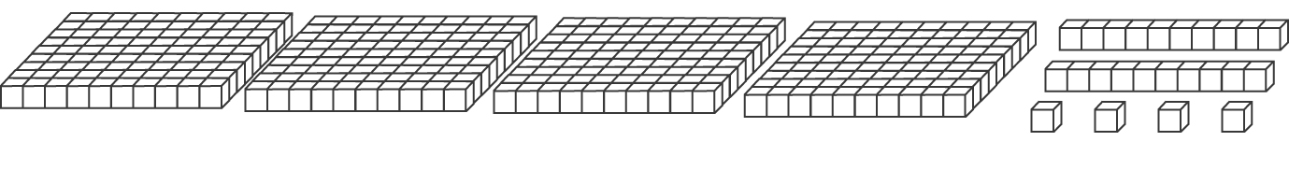

2. Find each quotient. Use Base Ten Blocks and place value.
Record your work.
a) 264 ÷ 3

c) 639 ÷ 4

Topic 5: Long Division

1. List the 4 steps of long division:
1) _____________
2) _____________
3) _____________
4) _____________

2. Find each quotient, using long division.
a) 925 ÷ 6 = _______ b) 376 ÷ 5 = _______

c) 388 ÷ 2 = _______ d) 930 ÷ 9 = _______

3. For each question, list the:
a) Dividend: ________________________________
b) Divisor: _________________________________
Topic 5: Word Problems
1. Dana is making packages of 6 pencil crayons.
She has 710 pencil crayons.
How many packages of pencil crayons can Sydney make? ______

2. Tickets to a school play cost $8 for an adult and $5 for a child.
Sixty adult tickets and 45 child tickets were sold.
How much money was made on the sale of tickets? _______

3. Cameron’s dog, Blackie, eats 21 kg of dog kibble in 3 weeks.
How much kibble will he eat in 10 weeks? _______

