**[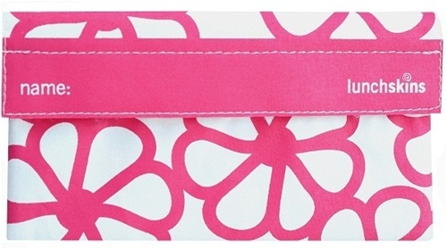](http://www.lunchskins.com/product-p/r-flwr-snk-ls2-0913.htm)[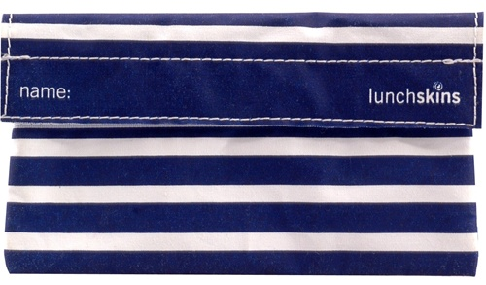](http://www.lunchskins.com/product-p/r-strp-snk-ls2-0901.htm)Re-usable Lunch Bags Order Form**

**[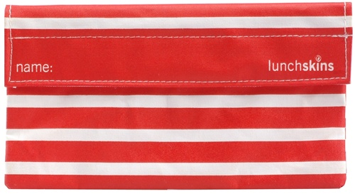](http://www.lunchskins.com/product-p/r-strp-snk-ls2-0902.htm)[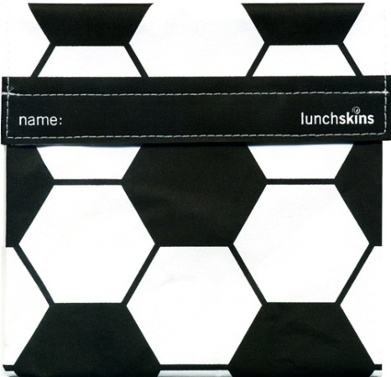](http://www.lunchskins.com/product-p/r-soccer-ls1-1202.htm)**

Reusable Snack Bags - Red Stripe

Price – Dhs 30 <http://www.lunchskins.com/product-p/r-strp-snk-ls2-0902.htm>

Reusable Snack Bag – Berry Flower

Price – Dhs 30 <http://www.lunchskins.com/product-p/r-flwr-sandw-ls1-0918.htm>

Reusable Sandwich Bags - Black Soccer

Price – Dhs 35 <http://www.lunchskins.com/product-p/r-soccer-ls1-1202.htm>

Reusable Snack Bags - Navy Stripe

Price – Dhs 30 <http://www.lunchskins.com/product-p/r-strp-snk-ls2-0901.htm>

Reusable Snack Bags – Navy Stripe order # ___

Reusable Snack Bag – Berry Flower order # ___

Reusable Snack Bags - Red Stripe order # ___

Reusable Sandwich Bags - Black order # ___

Total #___