Mechanisms Using Electricity Unit
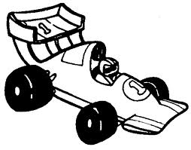
Topic: Building A Battery Powered Vehicle

Dear Grade 5 Parents,

As the students have keenly been awaiting, we are about to begin the “Building Electrical Devices” unit in science! All major concepts have been learnt about circuits, now it’s time to put this new knowledge into action. Throughout the next 4 weeks, students will build their own electrical powered vehicle. To get to started, we are asking the following to be brought to school by Sunday, January 20th:

- 50 dhs - covers the cost of the car kit including all electrical components and base materials needed for the cars. Students will keep all materials after their car has been built. CIS is covering a portion of the costs as well.
- shoe box - holds supplies while building
- other materials – anything you think could be useful for the construction of the vehicle (ie. Clear plastic for windows, fake lights for headlights, lego men for passengers, etc.). These materials can be brought in over the course of the unit as students think of other ideas

All work will be done during science class by means to ensure students complete this project using and further developing their own planning, problem solving and time management skills.

At the end of the unit, we will be hosting a “Race Day” to test the vehicles. The exact date has not yet been set, but will likely occur the week of February 10th – 14th. Parents will be invited to cheer on the racecars! Further information on exact times of our “Race Day” will be provided by the end of January.

Thank you very much for supporting your student in this exciting project! If you have any questions about this project, please contact Ms. Shannon or Ms. Cassie.

Sincerely,

Ms. Shannon
Grade 5S Teacher

Due: Sunday, January 20th

I have enclosed 50 dhs for the car kit my child, _____________________________, will be receiving for the building and construction of his/her electrical powered vehicle.

