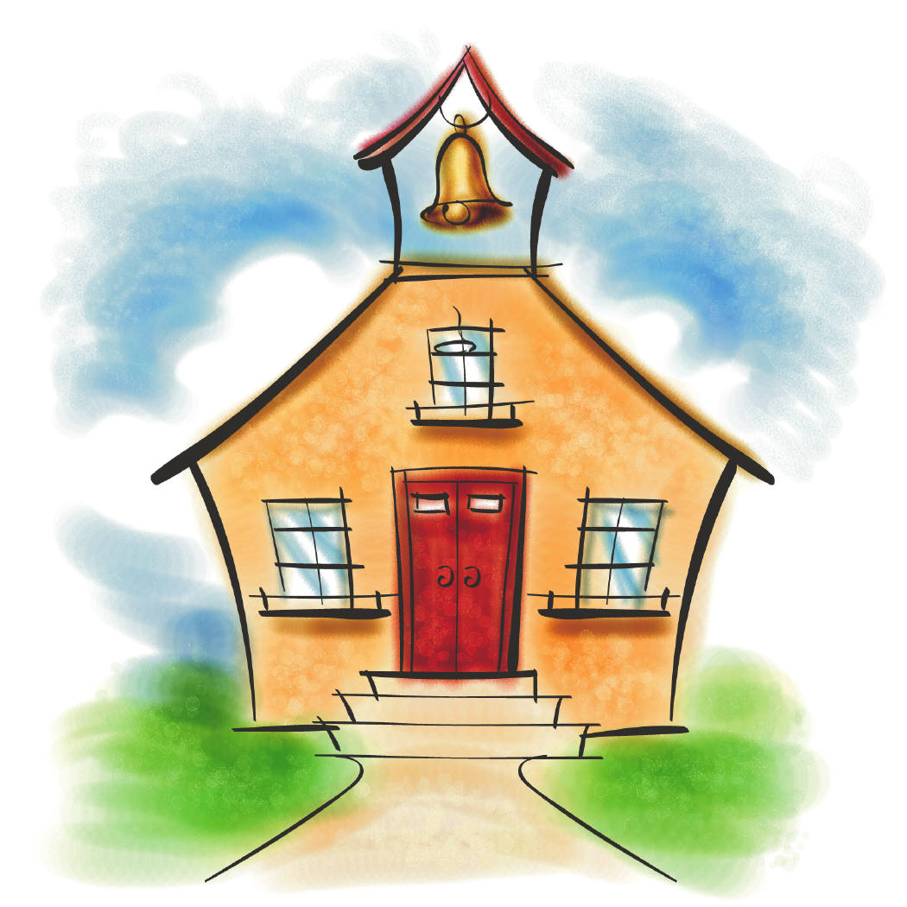Dear Parents and Students,

Hello and welcome to Grade 5 at CIS! I hope everyone enjoyed the summer and are ready to get started on what will be a great year. For those of you who are returning to CIS, and to the new families the school community, I am very excited to get to know each and everyone of you!

This newsletter will provide you with an introduction to myself, a few updates and will also inform you about important messages in our classroom.

Please, read over the next few pages with your child. These pages will outline the classroom policies, discipline, and answer some questions you may have about the school year. Be sure you talk about what is in the packet with your child. The last page will need to be signed by both the student and parent and returned to me by Wednesday, September 5th. This page tells me that both the parent and student know and understand the rules, consequences, and expectations for this year.

This year will be my first at CIS, and also the first year as a grade 5 teacher. I recently graduated with my Bachelor of Education, with a specialization in upper elementary, from the University of Calgary. Along side going to university both for my BEd and BA, I have been involved in extra curricular activities, which lead to my nomination for the Presidents Award for Excellence in Student Leadership! My main passion lies in the sport of synchronized swimming. In 2006, I created and swam on the University of Calgary Dinos Synchro team (who won the gold medal at CIS in 2009 & 2012), coached a team of 13-15 year old girls with the Calgary Aquabelles at the National Age group level, and also worked as an international consultant in Aruba coaching the team to the 2011 PanAmerican Games, in Guadalajara Mexico.

MCj03967440000[1]I am glad you are all here and can’t wait to get started!

MCj03967420000[1]

Sincerely,

Miss. Shannon Benson

**My Teaching Philosophy**

My goal for this year is to help your child to be an independent and responsible learner, as well as, to show him or her how to make responsible choices. To accomplish this goal, there will be regular homework and we will be making the most of our class time. My expectations for the students this year will be high, therefore all students will need to work hard and do their best. As the students will begin to realize, the amount of time we have for ‘fun’ is up to them – they have to earn it!

**Uniforms**

All student must be wearing the CIS school uniform at all times. From grade 4 up, the PE uniform will not be allowed to be worn other than during PE class. All grade 5 students must be changed for PE class – no exceptions! The office will be calling parents or students who are coming to school in clothes other than the school uniform.

**Homework**

In grade 5, please expect your child to be receiving homework on a regular basis, but not necessarily daily basis. In most instances, homework is generally work that has not been completed during class time and therefore needs to be completed at home in order to meet deadlines. Please know that I do not believe in assigning “extra” homework, unless there is a special reason for it. Homework is expected to be complete and brought back to school on the day it is due. Furthermore, if books are sent home, these also need to be returned the next school day, as the students need these materials to work at school.

Homework not done will result in the following consequences:

* The assignment needs to be finished, at the expense of recess
* Stickers on individual sticker chars will be removed for work not complete.
* A call will be made after 2-3 days of a missed assignment.
* If it continues to be a problem, a homework contract will be sent home which will need to be signed by both the parent and student.

Please discuss with your child the importance of organization and remaining on top of schoolwork ☺

**Lates & Absences**

Daily attendance will be taken in homeroom each morning. The school has updated to a new computer system this year, so in order for attendance to be submitted on time, all students need to in homeroom as soon as the 8:00am bell rings. If tardiness become an ongoing problem, parents will be contacted at home. In the event of a medical appointment, family holiday or any other prearranged reason your student will be away from school, please notify myself as soon as possible as this allows me time to plan accordingly.

We all get sick from time to time, so when this happens, please notify both the school as well as myself via email. Homework Buddies will be assigned to those who are away, and a file of all missed handouts will be created for the student.

**Tests**

Test dates will be given at least 1 week in advance. Please do not panic about this as my goal as the teacher is to ensure the students are well prepared and have the capability to be successful! With this, I strongly encourage review at home, even if a test is not around the corner.

In advance of major unit exams, study guides will be provided 1 week prior to the date of the exam. These will serve as an excellent resource for review of major concepts we have learned. Please be aware that questions on the test will appear in different formats that what is listed on the study guide as this provides further insight into critical thinking skills. Content, however, will remain.

All major tests have to be signed by a parent and returned the next day. Thanks for helping our grade 5’s stay on track!

**Supplies**

Thank you very much to everyone who has sent in school supplies! Having the right tools in our tool kits is an essential part of making the day run smoothly, so thank you again! All leftover supplies will be stored at the school in a plastic bag with each child’s name on it. This will allow us to grab any extra supplies as they are needed.

This year in science we will be creating a number of great science experiments, and in order to make these projects extra creative – we will be starting a ‘class materials’ box for all students in our class to access. A further list of supplies will be sent home when we begin our units, but please feel free to send in supplies at any time and we will gladly accept them. To give you an idea of supplies we will be interested in collecting, here’s a preliminary list: elastic bands, toilet paper rolls, and magazines with color photos. Thank you in advance for helping to inspire young the minds of our grade 5 class!

**Agenda & School Time Table**

On a daily basis, our class will be using agendas as they are an excellent tool for keeping track of homework and sending messages. If one parent could please initial the agenda each night, it will help students stay on top of their school work – thank you in advance! I will check for initials each morning and provide a sicker at the end of each week if all 5 days have been signed. Stickers are related to prizes and privileges… so the more the better!

Also, once the school timetable has been finalized, this will be shared with you. Swimming and PE will not be running this week, but will commence the week of September 9th, so those towels can stay at home a little longer!

Thanks for your patience; it is appreciated!

**Rules & Expectations**

In our classroom, expectations for student behavior are high and will be enforced constantly.

1. The number one rule in our classroom (“The Golden Rule”) is to treat others as you wish to be treated in return.
2. RESPECT each other, yourself and our classroom space. Be positive, use kind language, think before you act, and be patient.
3. Come to class prepared with all supplies needed for the day.
4. We need to work at a respectable volume. I have a volume indicator that I use to let us know how voices should sound during a task.
5. If you need to use the washroom, or grab a drink, please ask myself, and take the bathroom pass with you. Bathroom passes are not available while I am teaching a lesson.
6. You will each be assigned a number (1-24). This number is so we can quickly get in line in alphabetical order, and hand in assignments on time.
7. If you have a question, please raise your hand and ask politely.
8. When one person is speaking, full attention will be directed toward this person. This is expected when either the teacher or classmates are speaking.
9. I use the visual timer to let you know how much time you have to complete an assignment.
10. If you are away, I will keep your missed work in a file folder. You are responsible for getting the folder, and asking your helper buddy what work you missed.
11. We will have a seating plan, which may change every 2-3 months, depending on classroom dynamics.
12. At the end of the day or class, I dismiss you – not the bell.

**Consequences**

If classroom rules are broken, consequences will follow in accordance to the severity of the misbehavior. Here is what can be expected:

* I will give you a warning to choose a better learning choice.
* You can miss lunch/recess activities or be asked to stay after school
* You will be asked to visit Ms. Maria or Mr. Darcy.
* I will call home and/or email home to discuss with your parents/guardians
* We need to look at alternative arrangements for your learning. Working in the office, an alternate classroom, etc.

**Rewards**

Rewards will be given for various reasons throughout the week, both on an individual basis by means of a sticker chart and as a class with our gem jar. The type of rewards will also range from pencils and erasers to class popcorn parties and extra recess… and even Miss. Shannon joining you at swimming!

**Class Website**

MCj04241780000[1]Our class has it’s very own website! To view our website, please visit [www.missshannongrade5.weebly.com](http://www.missshannongrade5.weebly.com). On this page, you will find upcoming events, due dates, homework assignments, and links to other websites, including our schools new facebook page! Check the links often to keep an eye on up-to-date announcements, both from the CIS administration and myself ☺ Hopefully you will find this helpful!

**Emails**

If at anytime you have questions, comments, concerns, please do not hesitate to contact me via email and I will get back to you within 24 hours. Please know that during school hours, your child’s learning is of paramount importance to me and my attention will first be directed toward the students, rather than my email account. This is why I ask for a 24 hour window of time in replying to your email ☺ For any matter that may take more than a paragraph to answer, face to face meetings are preferred, so please do not hesitate to set up a meeting with me. To do so, please call our receptionist Miss. Leslie. She will then assist you with booking a meeting. Communication is very important to me as I believe in a triangle approach, branching the teacher, parents and the learner.

My email address is: [sbenson@cisabudhabi.com](mailto:sbenson@cisabudhabi.com).

**Snacks and lunch**

Please be sure your child brings a water bottle, snack, and lunch with them to school everyday, as it is important to eat healthy during the day to keep energy levels up. Please do not send pop (soda) or energy drinks to school. Pop will be reserved for special days only, which I will inform you about. Fruit, veggies and sources of protein are the best types of food to nourish young minds at work – thanks for helping to keep our grade 5 class healthy!

**Buses and Pick-up**

If your child is NOT going home on the bus, or is being picked up by someone else, or is doing an after school activity outside of the norm, please send me a note in the agenda, call the school and leave a message at reception. This helps us know where our students are supposed to be and who they are to be leaving with. Bus drivers also need to be informed, which I can then help with!

*Thank you to everyone for your help and support to make your child’s year a GREAT one in grade 5! I really believe parents and teachers must work together to ensure success for a student.*

*~ Miss. Shannon*

**Return Me!**

Thank you for reviewing your student’s packet. Now, all you have left to do is remove this page from the packet and sign the middle of the page with your student by Wednesday, September 5th. Thanks!

I have read and understand the rules, expectations, consequences, and rewards that my child will be held to in his or her classroom.

_________________________________

Student name (print)

_________________________________ _____________________

Student Signature Date

_________________________________

Parent name (print)

_________________________________

Parent Signature