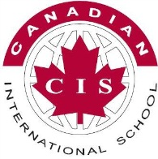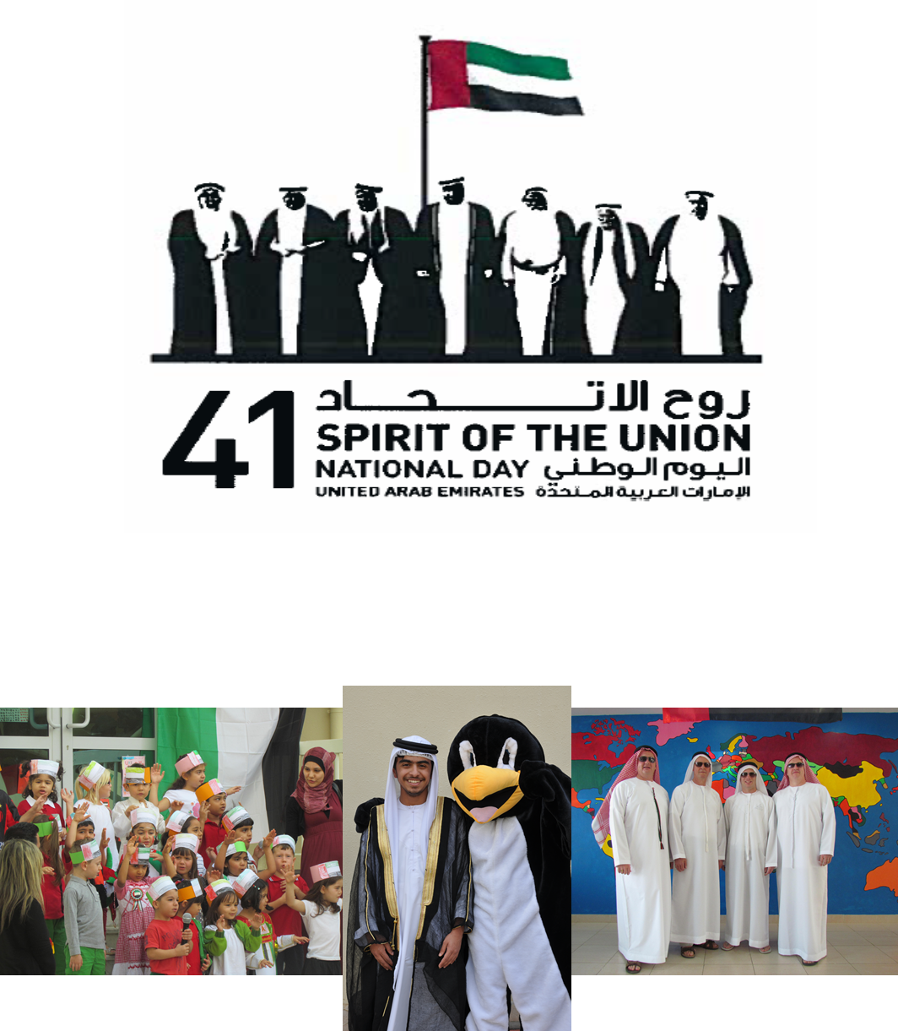

**PROGRAM**

12:00pm – 1:00pm

Student *(Arabic 1 & 2)* Cultural / Dance Performances in Courtyard – All Grades

1:00pm – 3:00pm

***Happy Birthday UAE Festival***

Students will participate in a variety of cultural, local, and historical events/exhibits

UAE history, live band/singers, cooking demos, falconry, henna,

camel rides, local food, etc

**Our CIS celebrations will take place from 12:00pm – 3:00pm**

***on***

**NOVEMBER 29th, 2012**

**U.A.E. NATIONAL DAY**

**CELEBRATIONS**

**Please come and join with us as we celebrate the birthday of the UAE – a country that we are all honored and priveleged to be living in. Join us for a celebration of culture, heritage, and history with performances, activities, and displays to mark the**

**41st birthday of the UAE**